|  |
| --- |
| **INDEPENDENT UNIVERSITY, BANGLADESH** |
| School of [Engineering and Computer Science](http://www.secs.iub.edu.bd/)    **PROJECT: Online Management System**  **By Team: Byte.M3**  Syeda Sutapa Rahman Meem-1530232  Sadek Hossen Leon -1521818  Kazi Imdadul Hoque -1522248  Syed Shams Elahi -1621176  Instructor: Radiah Rose Haque  Date: 23/06/2018 |
|  |
|  |
|  |

**Declaration of Originality**

This project is all our group own work and has not been copied in part or in whole from any other source except where duly acknowledged. As such, all use of previously published work (from books, journals, magazines ,internet ,etc ) has been acknowledged within the main report to an entry in the References list.

Abstract

A management system is a project which goals in growing an automated System’s to keep all the everyday work. Our university management system will do this for libraries and notice boards. This task has many functions which are usually not available in regular library management systems and online notice boards like facility of consumer login and a facility of instructors login .It also has a facility of admin login through which the admin can screen the complete system .It additionally has facility of an online observe board in which instructors can student can placed up data approximately workshops or seminars being held in our university or close by universities and librarian after right verification from the concerned organization organizing the seminar can upload it to the notice board . it has also a facility in which student after logging of their accounts can see listing of books issued and its issue date and return date and additionally the students can request the librarian to add some new book by using filling book request form. The librarian logs into his account, which is the admin account, then they can generate several reports like student report, issue report, teacher report and book report. All in all, this project of ours is being developed to aid the students and staff of library to manage the library in the most efficient way viable and also minimize the human tasks. It will also provide a complete fully functional notice board online for the university.

Table of Contents

Abstract 2

Table of Contents 3

Additional Materials on the Accompanying CD 4

Acknowledgements 5

1 Introduction 6

1.1 Background to the Project 6

1.2.1 (*eg*) Gather client and user requirements 7

1.2.2 (*eg*) Analyse and model the requirements 8

1.2.3 (*eg*) Investigate possible solutions, etc, etc 9-11

1.3 Overview of This Report 12

2 Literature Review 13

3 Methodology 14-16

4 Requirements 19

5 Analysis 20

6 Design 21

7 Implementation 22

8 Testing 23

9 Project Management 24

9.1 Project Schedule 24

9.2 Social, Legal, Ethical and Professional Considerations 24

10 Conclusions 25

10.1 Achievements 25

10.2 Critical Appraisal 25

10.3 Limitations 25

10.4 Future Work 25

11 Group Reflections 26

12 Bibliography and References 27

13 Appendix A – Project Specification 28

14 Appendix B User Manual 29

15 Appendix E – Project Presentation 30

16 Appendix X – As required 31

Acknowledgements

The project we submitted herewith is a result of our own effort in totality and in every aspects of the project works. Materials, which we used in the project found by web site, are mentioned by reference. All the information that has been obtained from other sources have been fully acknowledged. We understand that any plagiarism, cheating or collusion of any sorts constitutes a breach of University rules and regulations and would be subjected to disciplinary actions.

The satisfaction that accompanies that the successful completion of any task would be incomplete without them ention of people whose ceaseless cooperation made it possible, whose constant guidance and encourage men to crown all efforts with success.

We are grateful to our course instructor ,Miss Radiah Rose Haque, for the guidance, inspiration and constructive suggestions that helpful us in the preparation of this project.

We also thank our Student on Duty (SOD), Rabbi Iqbal, who has helped in successful completion of the project.

**Syeda Sutapa Rahman Meem -1530232**

**Sadek Hossen Leon-1521818**

**Kazi Imdadul Hoque -1522248**

**Syed Shams Elahi-1621176**

# 1. Introduction

This chapter provides an outlook into the motives, objectives, backgrounds and operation environment of the system.

# 1.1 Background

A University Management System has 2 sub components.

They are:

1. Notice Management System
2. Library Management System

A Notice Management System is an application which enables the staff members of a University (Registrar’s office, Faculties) or organization to make notices and important dates or updates available to everyone involved with ease. Notices regarding makeup class, holidays and exams can be posted and seen only by those in the organization or University.

A Library Management System is an application which refers to library systems which are generally small or medium in size. Librarians use it to maintain the library using a computerized system where they can record several transactions like issue of books, return of books, addition of new books, addition of new students etc. Books and student maintenance modules are also incorporated in this system which would track the students who use the library and also an informative description relating to the books a library contains. With this computerized system there will be no loss of book record or member record which generally happens when a non-computerized system is used. Moreover, a report module is also added in this Library Management System. If user’s position is admin, the user is able to generate different kinds of reports like lists of students registered, list of books, issue and return reports. All these modules are able to aid the librarian to maintain the library with more ease and in a more sustainable way compared to manual non-computerized library systems.

The Integrated library management will keep all records of a library operation such as items, bill, paid, and also patrons’ record. Using this software we can operate all the library operations with ease. Integrated library system there is two interfaces one is patron and another one is for library staff. In library system the operation of a user/member/patron and staff of library is different. A user can search a book, view book list which are available in library, can issue book, renew book, can hold book, can print issue list, can edit his/her information (patron information). Online public excess catalogue, circulation, some function under serial control can operate by patron. But a staff can store bibliographic (book, CD, DVD, journal etc.) record actually library materials record in database, can create patron in database, order a book, purchase a book. Acquisition, cataloguing, some function under serial control, management all are operate by staff of a library.

Modern Generation is going to dependable on computer and through computer we use Software. By using this, we can store a student’s information, issue a book and store a student’s information are used by library administration.

Libraries are essential in a process of giving citizens access to knowledge. In digital times they are needed more than before. In our country, library systems are written that’s why we make great use of paper. By making paper we cut trees. It is very harmful for our environment. For our environment, we take this step to reduce this. This increases environment friendliness and company profits.

The Management System will cut down the amount of human resources required by the company as much of the Tasks of putting up notices and maintaining documents, printing, and managing forms can be done online by an individual. Thus increasing the profit.

All these combined will help make the organization take a step into modernization, be more competitive and updated as other companies using the latest technologies, improve the outlook of the company, overall making the current existing model a new transformed and much better oiled machine.

# 1.2 Objectives

The aim of this project is to develop a system that can handle & manage the activities involved in a library management and university notices in an efficient & reliable way. Less managing personnel & easy searching availability and user profile managing are major goals in this project.

The project goals and objectives that will be gained after completing this project are discussed in this subchapter. The aims and objectives are as follows:

* Develop a system that can replace the manual library managing system.
* Develop a database which stores user details and book details.
* Give reliable search facility for the user.
* Administrator or librarian should have logins.
* Create an easy to understand user friendly environment.
* Attractive user interfaces to navigate through the system for the users.
* Develop the system documentation with detailed UML specification.
* The option for students to search online for books in the library
* See if books are reserved, available or borrowed
* Advanced search features to find books
* A student interface with the options for account creation, login, and forgot your password
* Student accounts can see books they have borrowed, due date, and can borrow new books
* Student accounts can also see books which students with similar tastes or departments have borrowed
* A library staff interface with the options for account creation, login, and forgot your password
* Library staff accounts can see total number of books in library, which are available, which are borrowed, which are reserved
* Library staff can add new books, edit their details, or remove existing books
* Library staff accounts can issue books to students, and verify student accounts
* A notice board web site showing all upcoming seminars, workshops and events or new facilities in university
* University staffs can update notice board and modify it as required on timely basis
* Students can give their reviews and comment on books
* An all access super-user account which has permission to access and privileges to everything
* Special permissions to access and privileges for each type of accounts
* Search filtering
* Special filter sidebar
* Email notification on withdrawing books, and reminder of return date, and if overdue, with fined amount
* Secure password
* Login using Facebook
* Responsive stable web application for all platforms
* A university site page with notices, and information about events, and date and venue
* Departments or register office or staff can add, update, delete events
* Students can see event information
* Has a Powerful look for engine
* Maintaining any media
* Help and User's Guide
* Book issuing books Online
* Requesting column for librarian for providing new books
* a separate digital library repository
* Student login page where student can find books issued by him/her and date of return.
* A search column to search for books
* A teacher login page where teacher can add any events being organized in the college and important suggestions regarding books.
* Online notice board about the workshop.
* A librarian login page.

**Elaborated:**

* The Management System will can be signed up by students, faculties, library and Registrar’s office staff members. The students will need their student ID and IUB email address to be verified. The rest will be verified by their Faculty or Staff ID and email address.
* Using our Management System, the staff from the Registrar’s office or faculties can login online and post notices in this online notice board.
* The Library staff can login and add new books, see which books (and which copies) are available and withdrawn and overdue, and request for new copies of lost books.
* The students will receive notifications of new notices, and book withdrawn, due back period, and if book is overdue, and fined amount by email. They can also log in and comment and rate books and get suggestions of similar books which students with similar courses have taken.
* There will be certain set of permissions, the Library staff account can add, remove, delete and view all books available and on loan, and also the fined amount, and can verify student’s accounts if required and adjust fines.
* The Registrar’s office staff or faculties accounts’ can add notice, delete notice, schedule workshops, and exam dates online.
* The students can view books, and notices and see which books they borrowed and due date, and fined amount if any. They can also see what similar books students took and comment on those.
* There is also email verification and confirmation where appropriate (loaning books, creating account, due date, overdue).
* It can remain complete records of a file; it can be a documents, registers, books of any type etc.
* It can be appended while got any new arrivals.
* All of the user can find the way through the database and locate a document of their choice.
* A non-member or member can search a book without consulting library staff in a network environment, where in several PCs of different department which are connected.
* It has huge search facilities along with point search facility where, an exacting item/string in a given field of a specified period may be search at finger tips.
* Presented records can be edited only by an allowed person.
* Authorized person/administrator they can change the password at any time to prevent people who want to hack the password.
* New members can only be registered by the library administrator or certified person.
* Member's photograph and signature can be integrated and may be confirmed at the time of issuing any paper.
* The software can give the subsequent information at finger tips:
* The software will store the Issue or return records of any file.
* Then it also store the Issue or return records of a member.
* Details of all papers issued from the library on time.
* These will make the activities for our major stakeholders – faculties, Registrar’s office staff, Library staff, and students – quite streamlined, efficient, rapid, flexible and smooth , automating the entire process, requiring less manual work.



# 1.3 Overview of This Report

This report is the first part of multiple submissions of a complete report. It also includes with it a working functional prototype.

In the initial (previous) sections we have provided the background and information on our project, and our objectives and goals, which will make it clearer of the parts that are to come. It will make it more evident on why we are choosing to do the task as follows.

In the subsequent sections we provide a literature review, analysing what a basic management system does, and why our proposed system is more viable and desirable than the currently existing ones.

We go on to explain the development methodology we have used in our implementation and the basis for using it.

# 2. Literature Review

In this project we are working on Management System. A Management System includes a Library Management System (LMS) and an Online Notice Board System. A Library Management System (LMS) is a device to help any libraries and institution which are still using the old system to manage their library. The old way like searching for a book using manual work is scrap, fast report generation is not possible, information about issue/return of the books are not properly maintained, no central database can be created as information is not available in database. But by using the system, user can overcome all the problems mentioned above. This system can manage all the process of the library. Book connections including book searching, personal book borrowing history details, availability of the book and appearance of the book and etc. can be very easily handled by this system. This system is suitable for small to big libraries including legal libraries and medical, university, schools, colleges, academic resource centers and other corporate houses .However, we have focused on LMS for universities and colleges.

LMS has three modules that’s are Administration Module, Staff Module and Students Module. First of all, Students Module allows students to search material by title, subject, publication, name/author, ISBN/ISSN, series and etc. it also allow students to find recently arrived material.

In Staff Module, staff can issue book and receive book with bar code. Staff also can fine for books received after due date.

Lastly, the administration module help administrator to register/convey shelf and category, issue library card, change book category , configuration to register users, and database backup/restore.

The Online Notice Board will enable staff members to post and update notices online with ease. This will make information regarding the organization readily accessible to everyone.

Overall this project of management system can be very helpful and it can make things easier.

## Study on existing MS

## 2.1Overview

Nearly all of the users are like to use a system which are already long exists and already have a positive status. Those people whom towards ICT; they may like to compare with some existing systems before they select one, as well as Management System (LMS). In this report, quite a lot of features, functions and comparison among the both systems will be discussed to understand better how a MS works and its main principle to help out universities, businesses and companies.

**Advantages of our MS:**

* Simple and easy to use
* Online interface easy to reach
* Supports all platforms as web interface
* Mobile responsive
* Can create, read, update, delete notices, book information and notices with ease and instantly
* A modern approach to automation and improving existing systems to stay up to date with recent technologies
* Helps build the library students’ community and allows them to interact
* Improve efficiency and productivity
* Increased library commitment
* Highly secure
* With MS, it helps most businesses to increase efficiency on their daily work such as reducing man power to manage books or to post notices in the university notice board, and manual activities subsequently improve productivity.
* Save time
* Dynamic reports
* MS reduces manual activities, man power and paperwork. With this programmed system, people which have multiple skills can be used more efficiently.
* Error free
* Mobile access
* Innovation

# 3.Methodology

* In this project we have used the agile methodology for our development. We have adapted this for several reasons.
* It has a lower cost, as there is always a scope for correction and changing the implementation and carry out something better as the project grows.
* It enables our clients to take part in the development process and voice what they require from our program and taking their feedback into consideration to make the end product better and making them happier.
* It enables us to openly communicate with the clients, take their suggestions and visions, and also show them what other alternatives we have and how we can make it better by discussing amongst ourselves.
* Debugging and testing becomes easier as we are constantly checking for defects and errors and fixing them as we go, and not at the complete end of the project. Thus making us more competitive in the market as well.
* Evaluating and preparation time is sped up greatly as each iteration consists of a small section of the entire project, so we can finish it and then focus on the next rather than the whole project.
* Assessments are made quickly and the product is evaluated at every stage of the process so as to make sure we maintain the best quality standards required.
* It is easier to make sure that our product is meeting the requirements requested at every stage.
* Communication with clients and systems makes the process transparent.

### High Product Quality

* High product quality is ensured through regular testing to make sure the product is working during the development phase.
* Requirements can be defined and broadened upon in the appropriate time.
* It enables continuous integration and regular testing into the development process.
* The software gets developed in incremental, quick cycles.

### Higher Customer Satisfaction

* High customer satisfaction is ensured by showing the working functionalities to the clients.
* It also makes delivering to the market faster and more frequently with every release of the products.
* Customers are involved and engaged in the process making them more confident on our product and enabling us to understand them better.
* If anything is not favourable or accepted positively, it can be quickly changed in the next iteration.

### Increased Project control

* Agile process enables more control over the project through daily sprint meetings and transparency.

### Reduced Risks

* Risks are reduced as small incremental developments ensures a small period between feature development.
* Agile gives the luxury when newer changes need to be incorporated.
* The client’s needs and preferences can be adapted to in the development process.

### Faster ROI

* The Return Of Investment (ROI) is quicker as it is more business focused, allowing the client to focus on the major features first.
* A functional ready to use product is made after a few iterations thus more beneficial.
* Customer reaction can be gauged and built upon as agile provides fast product releases.

## Early and Predictable Delivery

* Delivery dates are more predictable and sooner as a fixed schedule of sprints or iterations are used. This also enables the opportunity to release a beta or test a prealpha version if a sufficient model is completed before the due date.

## Predictable Costs and Schedule

* As the iterations are meant to be completed in a fixed duration, the cost of each iteration is predictable and fixed to the amount of work that can be performed by the team in that time frame. This makes it easier to estimate a cost for the client prior to each iteration and how the costs are arising with respect to the features. Additional features can also be thought of here.

## Allows for Change

Every iteration allows changes to be made to the product easily making it grow and develop.

## Focuses on Business Value

Focusing on business value is a priority as the features are developed in every iteration based on priority, step by step going towards a minimum usable output, then making better.

## Focuses on Users

Users are given top priority and this ensures the product is useful and tries to meet their demands every stage of the way.

## Improves Quality

* Small iterations of a large development process makes it easier for the development team to focus on high-quality development, testing, and collaboration. Frequent builds and tests and reviews through each iteration ensures better quality and identifies and corrects defects earlier.
* Small teams work better using agile development process as on developer can possess multiple skills and can utilize them at several stages of the iteration without conflicts.
* Agile welcomes changing requirements, even late in development process. Agile processes harness change for the customer's competitive advantage.

# 4 Requirements

To help gather the functional and non-functional requirements for developing our application suite, we used a number of methods. Below is a description of some of the tools used to collect these information.

**1. Brainstorming**

It is used in requirements induction to collect decent number of ideas from a number of people. Typically brainstorming is implemented in finding out all the possible solutions to problems and makes the detail of opportunities simpler. It casts a broad net, finding out many discreet possibilities. Prioritization of these possibilities is important to find needles in haystack.

**2. Document Analysis**

Document Analysis is a vital information-gathering technique. Understanding the documentation of a present system can aid when creating AS-IS process documents and also when driving the gap analysis for scoping of the migration projects. In today’s world, we will also be finding out the requirements that initiated the creation of an existing system- a starting point for documenting all of the present requirements. Pieces of data are mainly buried in current documents that help us in setting questions as a part of validating the requirement completeness.

**3. Focus Group**

A focus group is in reality the gathering of people who are customers or users representatives for a product to gather their feedback. The feedback can be gathered about opportunities, needs, and problems to find out the requirements or it can be collected to clean and validate the already elicited requirements. This type of market research is contrary from brainstorming in which it is a managed process with certain participants.

**4. Interface Analysis**

Interface for any software product will either be human or machine. Integration with external devices and systems is another interface. The user centric design approaches are rather advantageous to make sure that we create usable software. Interface analysis- analyzing the touch points with another external system- is crucial to ensure that we do not overlook the requirements that are not readily visible to the users.

**5. Interview**

Interviews of users and stakeholders are vital in making a wonderful software. With no knowledge of the expectations and motivations of the stakeholders and users, we are highly unlikely to satisfy them. We also need to understand the perspective of every interviewee, in order to accurately address and weigh their inputs. Like a good reporter, listening is a quality that assists an excellent analyst to get better value through an interview as compared to an average analyst.

**6. Observation**

The observation covers the analysis of users in their natural habitat. By watching users, a process flow, pain points, awkward steps and opportunities can be determined by an analyst for betterment. Observation can either be active or passive. Passive observation provides better feedback to refine requirements; on the same hand active observation works best for obtaining an understanding over an existing business process. We use these approaches to uncover the implicit requirements that are often overlooked.

**7. Prototyping**

Prototyping can be very beneficial at collecting feedback. Low fidelity prototypes make a good listening tool. Often times, people are not able to articulate a specific need in the abstract. They can swiftly review whether a design approach would satisfy the need. Prototypes are very efficiently done with fast sketches of storyboards and interfaces. Prototypes in some cases are also used as official requirements.

**8. Requirements Workshop**

Also known as JAD or joint application design, these workshops are beneficial for collecting requirements. The requirements workshops are much more organized and structured than a brainstorming session where the involved parties get together to document requirements. Creation of domain model artifacts like activity programs or static diagrams is one of the many ways to capture the collaboration.

**9. Reverse Engineering**

Reverse Engineering current management system models available to generate our own customized model.

**10. Survey**

When collecting data from many people, it is often time and cost ineffective - too many people, too little time, too much expense taking interview. Thus a questionnaire survey can be used. The survey insists the users to choose from the given options (agree / disagree or rate something).

### 11. Request for proposals (RFPs)

We request for requirements through an RFP. This is a list of requirements that is there for us to compare against our own capabilities to determine how close a match we are to the client's needs.

### 12.Use cases

Use cases are simply stories that describe how individual processes function. The stories include people (actors) and describe how the solution works from a user perspective. Use cases may be easier for the users to articulate, although the use cases may need to be distilled later into the more specific detailed requirement

# 5 Analysis

[ Depending on the project you need to include here a **business process model** or other high-level conceptual view of the required system, a use **case model** showing the **main usage scenarios, rich picture** etc. You need to **explain** the **models**, but diagrams save words!]

Management System Processes

In our model:

1. *The Staff consists of - the Library Staff, the Registrar’s Office Staff and the Faculty.*
2. *Types of Notice consists of - Holiday, Middle of Term Examination, Final Examination, Make-Up Class, Seminar, Workshop, Event, Competition*

*C) Authenticated Accounts consist of - Staff Account and Student Account.*

Our Online Management System can be accessed by going to https://www.domainname.org.

**Setting Up Account:**

I) **Sign Up** for Account Process:

1. *The Student or Staff goes to Site.*
2. *They navigate to the Sign Up page.*
3. *They put their personal details and University ID.*
4. *Verification email and SMS sent.*
5. *Confirmation of Staff account by Registrar’s Office Staff.*
6. *Signed Up.*

II) **Sign In** to Account Process:

1. *The Student or Staff goes to Site.*
2. *They navigate to the Sign In page.*
3. *They put their University ID and Password.*
4. *Signed In.*

**Permissions and Use Cases:**

I) All **Signed In User** can:

1. *View Notices on the Notice Board.*
2. *View Books available in the Library.*
3. *View Books they have Withdrawn.*
4. *View Due Date of returning Books.*
5. *View Fined Amount for Late Returning.*
6. *View Similar Books (people from similar Department also read)*
7. *View Ratings on Books.*
8. *View Comments on Books.*
9. *Add Comments on Books.*
10. *Give Ratings to Book.*

II) All **Staff Accounts** can:

1. *Add Notice to Message Board.*
2. *Delete Notice from Message Board.*
3. *Update Notice from Message Board.*

III) **Library Staff Accounts** can:

1. *Add Books to Library.*
2. *Remove Books from Library.*
3. *Update editions of Books in Library.*
4. *See list of Books Withdrawn by all* *Library Users.*
5. *See list of Books Withdrawn by a specific Library User.*
6. *See list of Overdue Books.*
7. *See list of Overdue Books by a specific Library User.*
8. *See Fined Amount on Books Overdue.*
9. *Verify Withdrawal and Return of Books and Fined Amount.*
10. *Verify Library Account.*
11. *Delete or Block Library Account.*

*IV)* **Registrar’s Office Staff Account** can:

*A) Verify* *Online Account.*

*B) Delete or Block Online Account.*

V) **All User Accounts**:

1. *Will receive E-mail Notifications for Notices or Library Updates.*
2. *Can change their Personal Details, Account Information and Password.*

VII) **Non Authenticated Users**:

*Cannot get access to any of these facilities.*

**Rich Picture:**

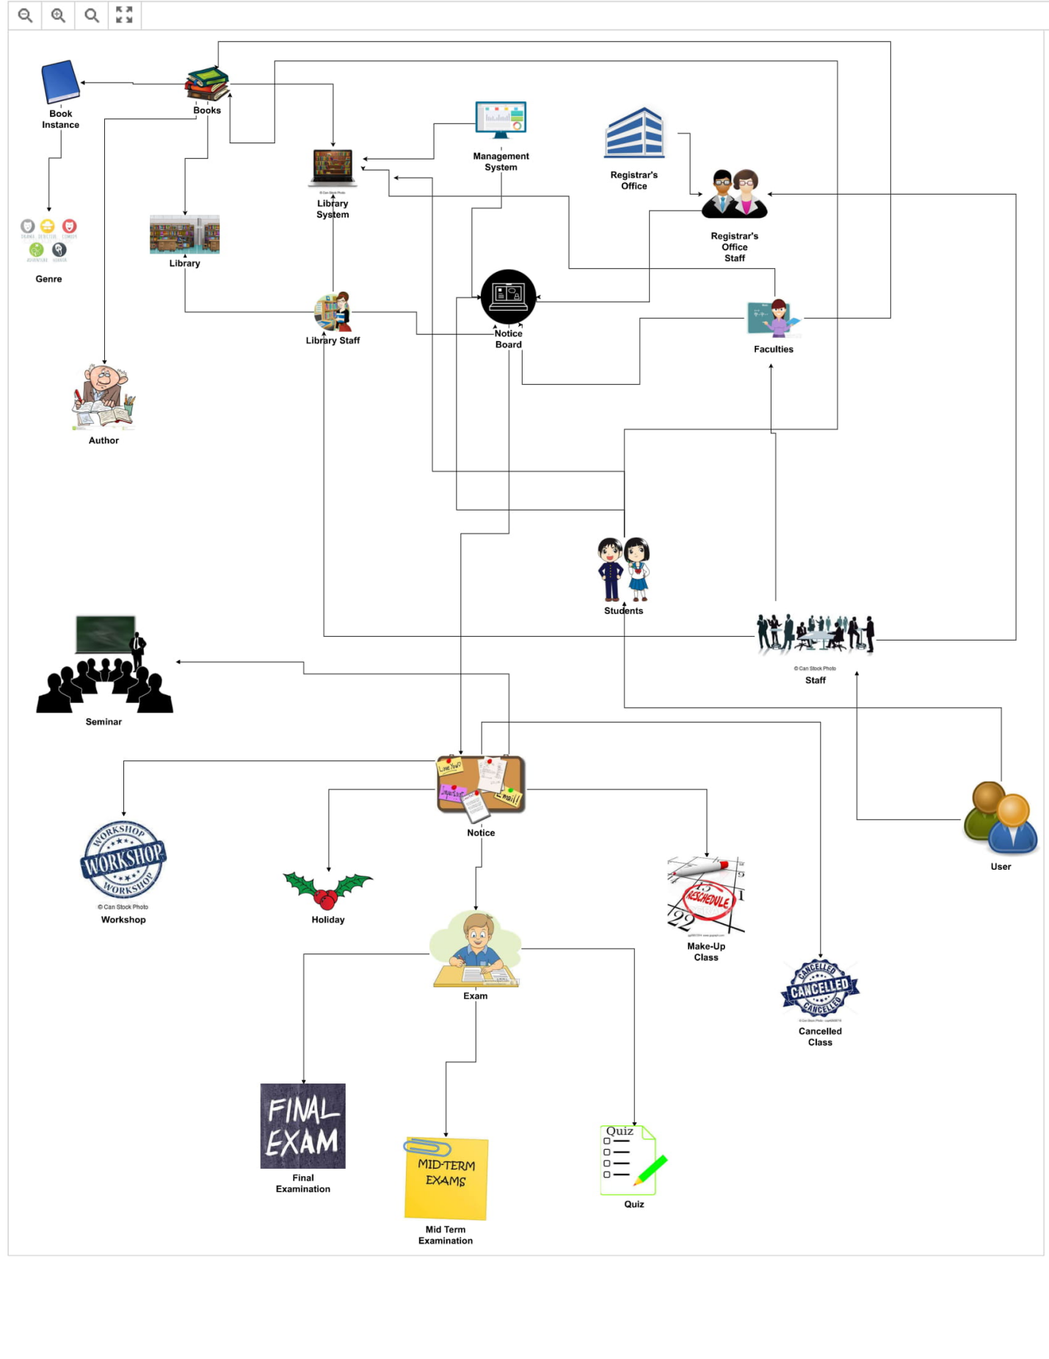

Table 1 Rich Picture of Management System

**Business Process Model Notation Diagrams:**

Due to the size and complexity of our project, and the number of possible processes involved in its usage and for the sake of time constraints, listed below are some of the BPMN diagrams for the major processes in our System.

*Account Registration:*

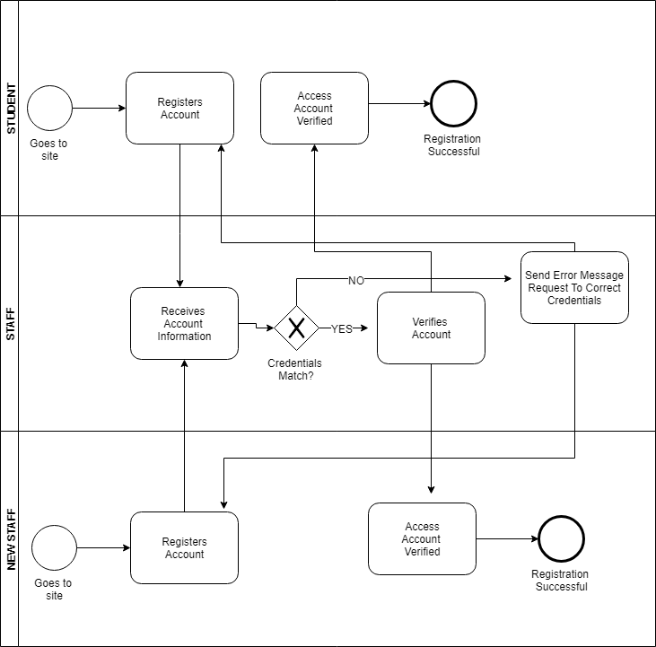

*Log In:*



*View Books:*

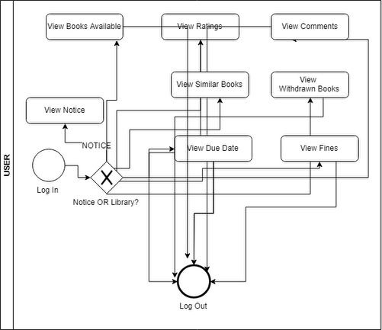

*Notice (Create - Read - Update - Destroy):*

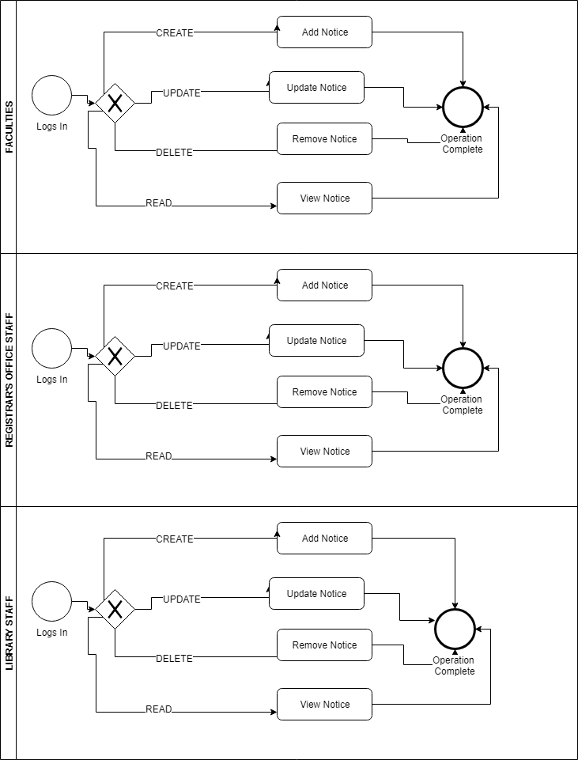

*Faculty Post Notice:*

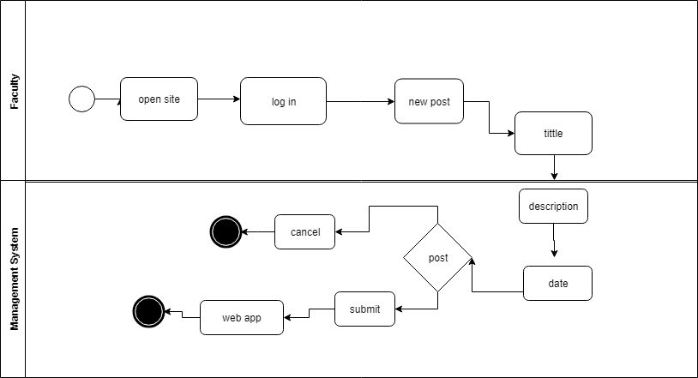

*Library Staff Post Notice:*

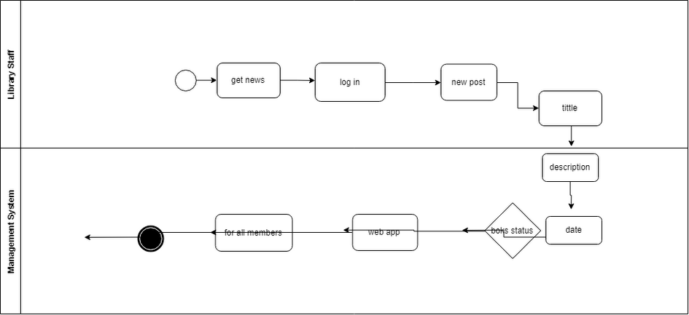

*Registrar’s Office Staff Post Notice:*

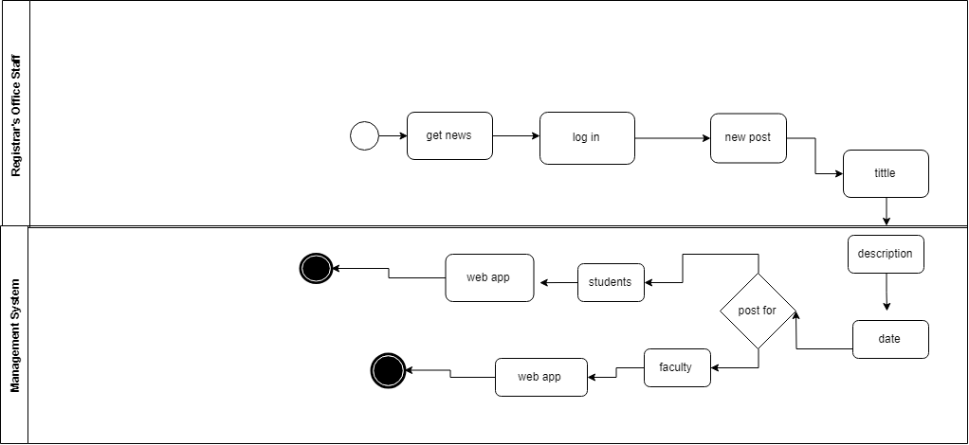

*Logout:*

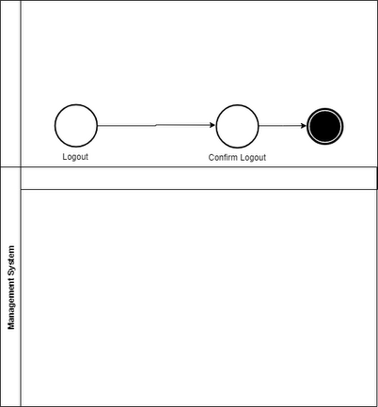

*Search Book:*

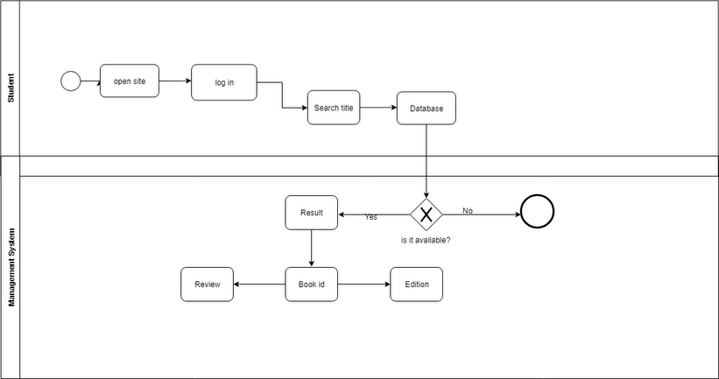

# 6 Design

# Our design model stands out from the existing systems in the following ways:

# One stop Management Solution:

# Most Management System suits come separately for the individual components. But our model brings all the different components and packages them (Library Management System, Notice Management System) as a bundled solution.

# B) 2-3 Factor Authentication and Verification:

# Authentication is done in a 2-3 step process:

# Through E-mail verification

# Through SMS verification

# Through Staff verification

# This makes the System very secure.

# C) Passwords Hash Encrypted:

# The password is handled through several encryption and hashing algorithms so as it will not go astray if any flaws in the system were to occur, nor will it be easily penetrable by any hacker.

# D) Fast, responsive, web-based technology:

# The entire System is web-based, requiring no additional hardware to set up and can be set up from a remote location from the developers’ office.

# The front-end is User friendly and made to enhance the user experience, and also make the application readily accessible through virtually minimal loading time.

# It is also responsive and supports all platforms and devices (mobile, tablet, PC, etc)

# E) Notifications all the way:

# Our solution notifies the End-Users of any changes or activities that is being done under their name as they occur. This is done through E-mail and SMS notifications. This ensures greater security and more user-friendly experience.

# F) Go paper free:

# Having automatized most of the manual tasks of recording and submitting details by the staffs and students and much of the task being conducted over the web, it cuts down the use of paper.

# G) Advanced Search:

# We incorporated an advanced searching feature to make searching for books efficient and easy.

# Users can locate books with no trouble without the help of any librarian.

**Enhanced Entity Relation Diagram (EERD):**

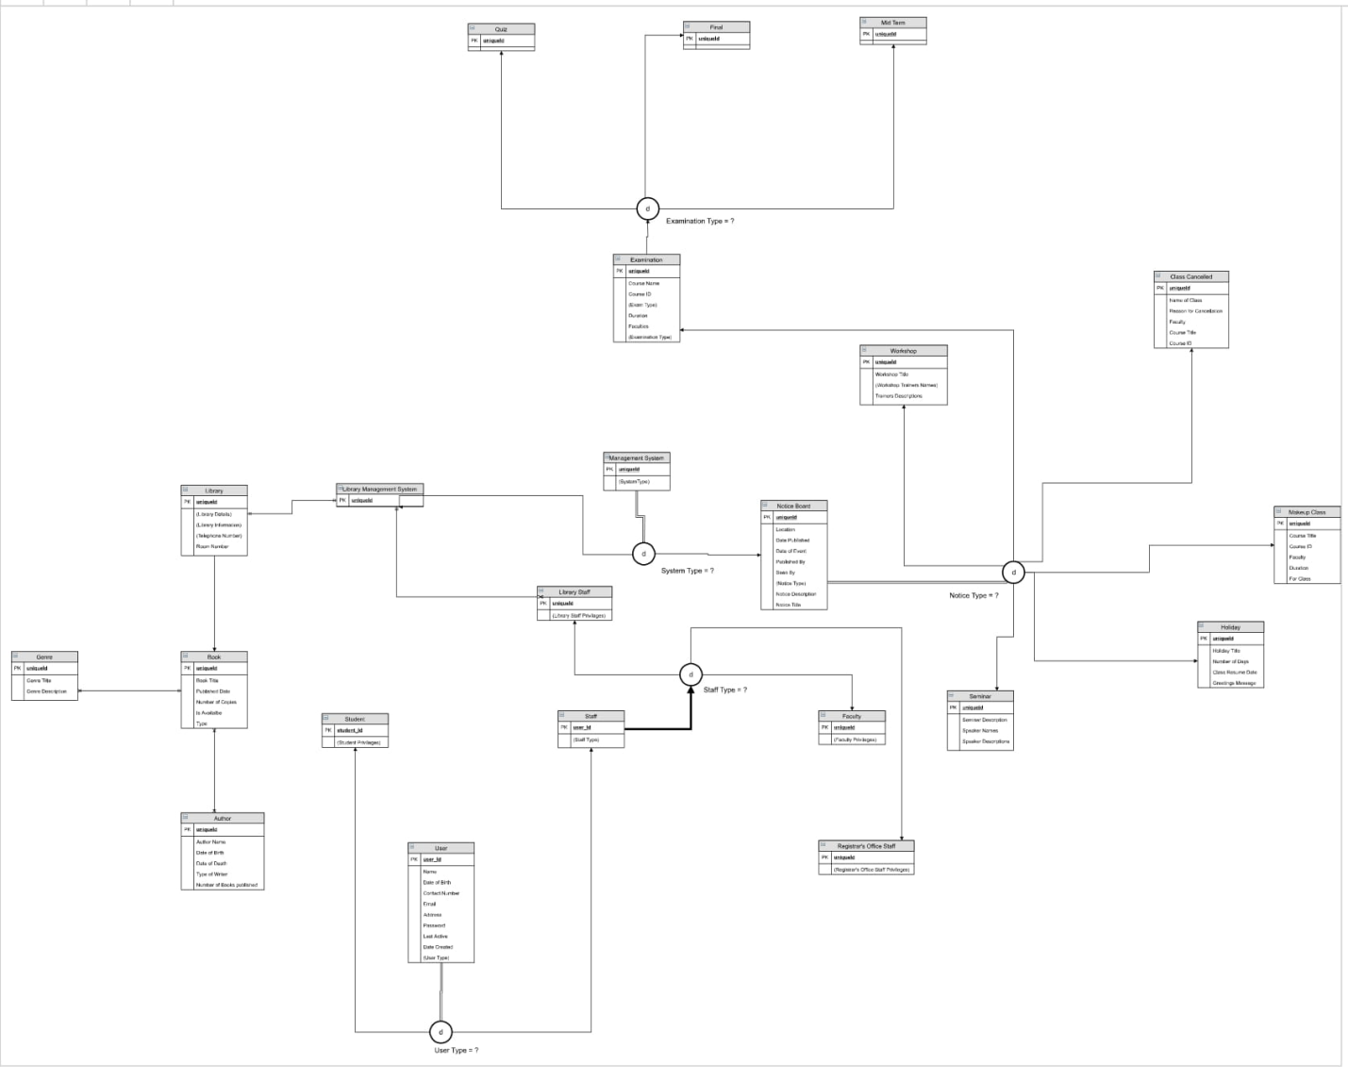

Table 2 Enhanced Entity Relation Diagram for Management System

**Data Dictionaries:**

|  |  |  |  |
| --- | --- | --- | --- |
| Name | Data Type | Size | Remark |
| Id(1,2,3,,4,5) | Number | Any positive number | This is the primary key of this relation. This contain the ID of the Authentication Group. Ex: 1 |
| Name(students,library staff,faculties) | Text | 300 | Name of the Authentication Group.  Ex: Students |
| Message_board_notice |  |  | Contains a notice as a Foreign Key. |
| Auth_user_groups |  |  | Contains a Auth User Group as a Foreign Key. |
| Auth_group_permissions |  |  | This contains the Auth Group Permissions as a Foreign Key. |

auth_group

|  |  |  |  |
| --- | --- | --- | --- |
| Name | Data Type | Size | Remark |
| Id | Number | Any positive number | This is the primary key of this relation. This contain the ID of the Authentication Group Permissions.  Ex: 1 |
| group_id | Number | Any positive number | Group ID from the Group Table as a Foreign Key.  Ex: 1 |
| permission_id | Number | Any positive number | Permission ID from the Permission Table as a Foreign Key.  Ex: 1 |

Auth_group_permissions

|  |  |  |  |
| --- | --- | --- | --- |
| Name | Data Type | Size | Remark |
| Content_type_id | Number | Any positive number | This is the primary key of this relation. This contain the ID of the Authentication Permissions. Ex: 1 |
| Codename |  |  | Ex: add_logentry,  Change_logentry,add_book |
| Name |  |  | Ex: can add log entry,can change log entry,can add group |
| Auth_group_permissions |  |  | This contains the Auth Group Permissions as a Foreign Key. |

Auth_permission

Auth_user

|  |  |  |  |
| --- | --- | --- | --- |
| Name | Data Type | Size | Remark |
| Id | Number | Any positive number | This is the primary key of this relation. This contain the ID of the Authenticated User. Ex: 1 |
| Last_login | Date-Time |  | This contains the Date and Time of the Last Login.  Ex: 2018-06-21 13:29:33.005402 |
| Is_superuser | Boolean | Yes/No | This contains the Boolean information if the User is Superuser or not.  Ex: Yes,  No |
| Username | Text | 100 | This contains the Account’s User Name.  Ex: Mdadul Hakqe |
| First_name | Text | 100 | This contains the User’s First Name.  Ex: Charles |
| Email | Email | 100 | This contains the User’s primary email.  Ex: Ratul_Shams@yahoo.com |
| Is_staff | Boolean | Yes/No | This contains the Boolean information if the User is staff or not.  Ex: Yes,  No |
| Is_active | Boolean | Yes/No | This contains the Boolean information if the User Account is active or not.  Ex: Yes,  No |
| Data_joined | Date | “YYYY-MM-DD HH:MM:SS, YYYY-MM-DD HH:MM:SS, “ | This contains the Date and Time of when the User Account was created.  Ex: 2018-06-21 13:29:33.005402 |
| Last_name | Text | 100 | This contains the User’s Last Name.  Ex: Dickens |
| Account_profile |  |  | This contains a Account Profile as a Foreign Key. |
| Django_admin_log |  |  | This is the admin log as a foreign key. |
| Catalogue_Book_instance |  |  | This contains the book instance as the Foreign Key. |
| Auth_user_groups |  |  | Contains a Auth User Group as a Foreign Key. |

|  |  |  |  |
| --- | --- | --- | --- |
| Name | Data Type | Size | Remark |
| Id | Number | Any positive number | This is the primary key of this relation. This contain the ID of the Authenticated User group. Ex: 1 |
| User_id | Number | Any positive number | This contains the ID from the User Table as a Foreign Key.  Ex: 1 |
| Group_id | Number | Any positive number | This contains the ID from the Group Table as a Foreign Key.  Ex: 1 |

Auth_user_groups

|  |  |  |  |
| --- | --- | --- | --- |
| Name | Data Type | Size | Remark |
| Sql_Query |  |  | SELECT * FROM 'auth_user_user_permissions' LIMIT 0,30 |

Auth_user_user_permissions

Catalog_author

|  |  |  |  |
| --- | --- | --- | --- |
| Name | Data Type | Size | Remark |
| Id |  | Any positive number | This is the primary key of this relation. This contain the ID of the Author. Ex: 1 |
| First_name | Text | 100 | This contains the First Name of the Author.  Ex: Charles |
| Last_name | Text | 100 | This contains the Last Name of the Author.  Ex: Dickens |
| Data_of_birth | Date | “YYYY-MM-DD” | This contains the Date of Birth of the Author.  Ex: 2018-06-21 |
| Date_of_death | Date | “YYYY-MM-DD” | This contains the Date of Death of the Author.  Ex: 2018-06-21 |
| Catalog_book |  |  | This contains the Book from the Book Table as a Foreign Key. |

|  |  |  |  |
| --- | --- | --- | --- |
| Name | Data Type | Size | Remark |
| Id | Number | Any positive number | This is the primary key of this relation. This contain the ID of the Book.  Ex: 1 |
| Summary | Text | 200 | This contains the text summary of the book.  Ex: ADD SUMMARY HERE |
| Isbn | Number | Standard ISBN number | This contains a standard ISBN number of the Book.  Ex: 4356457567523 |
| Author_id | Number | Any positive number | This contains the ID from the Author Table as a Foreign Key.  Ex: 1 |
| Catalog_bookinstance |  |  | This contains the Book Instance as the Foreign Key. |
| Catalog_book_genre |  |  | This contains the Book Genre as the Foreign Key. |

Catalog_book

|  |  |  |  |
| --- | --- | --- | --- |
| Name | Data Type | Size | Remark |
| Id | Number | Any positive number | This is the primary key of this relation. This contain the ID of the Book Genre. Ex: 1 |
| Book_id | Number | Any positive number | This contains the ID from the Book Table as a Foreign Key.  Ex: 1 |
| Genre_id | Number | Any positive number | This contains the ID from the Genre Table as a Foreign Key.  Ex: 1 |
| Catalog_book_genre | Number | Any positive number | This contains the Book Genre as the Foreign Key. |

Catalog_book_genre

|  |  |  |  |
| --- | --- | --- | --- |
| Name | Data Type | Size | Remark |
| Id | Text | 100 | This is the primary key of this relation. This contain the ID of the Book Instance.  Ex: 235452acaaea4632ba4749f3cb401032 |
| Imprint | Boolean | Yes/No | This is a Boolean data if the book is imprint or not.  Ex: Yes,  No |
| Due_back | Date | YYY-MM-DD | This contains the Due Back Date Time.  Ex: 2018-06-21 |
| Status | Text | A - Available,  W - Withdrawn,  M - Maintenance,  R - Reserved,  etc | This contains the Availability Status of a Book.  Ex: Available |
| Book_id | Number | Any positive number | This contains the ID from the Book Table as a Foreign Key.  Ex: 1 |
| Borrower_id | Number | Any positive number | This contains the ID from the User Table as a Foreign Key.  Ex: 1 |

Catalog_bookinstance

|  |  |  |  |
| --- | --- | --- | --- |
| Name | Data Type | Size | Remark |
| Id(1,2) | Number | Any positive number | This is the primary key of this relation. This contain the ID of the Genre. Ex: 1 |
| Name(horror,comedy) | Text | 50 | This is the Name of the Genre.  Ex: Horror,  Comedy |

Catalog_genre

|  |  |  |  |
| --- | --- | --- | --- |
| Name | Data Type | Size | Remark |
| Id | Number | Any positive number | This is the primary key of this relation. This contain the ID of the Admin Log. Ex: 1 |
| Object_id | Number | Any positive number | This contains the ID from the Object Table as a Foreign Key.  Ex: 1 |
| Object_repr | Text | 1000 | This contains the object string.  Ex: kumar,Anil,  Comedy,horror |
| Action_flag | Number | Predefined set of numbers. | This contains the action flag.  Ex: 1 |
| Change_message | Text | 1000 | This contains the change message description.  Ex: [{"added": {}}], [{"added": {}}] |
| Content_type_id | Number | Any positive number | This contains the ID from the Content Type Table as a Foreign Key.  Ex: 1 |
| User_id | Number | Any positive number | This contains the ID from the User Table as a Foreign Key.  Ex: 1 |
| Action_time | Date-Time | “YYYY-MM-DD HH:MM:SS, YYYY-MM-DD HH:MM:SS, “ | This contains the Action Date Time.  Ex: 2018-06-21 19:07:13.182173,  2018-06-26 13:22:36.450456 |

Django_admin_log

|  |  |  |  |
| --- | --- | --- | --- |
| Name | Data Type | Size | Remark |
| Id | Number | Any positive number | This is the primary key of this relation. This contain the ID of the Content Type.  Ex: 1 |
| App_label |  |  | This contains the app label.  Ex: admin |
| Model |  |  | This contains the model.  Ex: group |

Django_content_type

|  |  |  |  |
| --- | --- | --- | --- |
| Name | Data Type | Size | Remark |
| Id(1,2,3,4) | Number | Any positive number | This is the primary key of this relation. This contain the ID of the Migration.  Ex: 1 |
| App(contenttypes,auth,admin) |  |  | This contains the apps.  Ex: contenttypes,  auth,  admin |
| Name | Text | “NNNN_MIGRATION-NAME” | This contains the autogenerated Name of the Migration.  Ex: 0001_initial,  0001_initial |
| Applied | Date-Time | “YYYY-MM-DD HH:MM:SS, YYYY-MM-DD HH:MM:SS, “ | This contains the Migration Applied Date.  Ex: 2018-06-21 19:07:13.182173,  2018-06-26 13:22:36.450456 |

Django_migrations

|  |  |  |  |
| --- | --- | --- | --- |
| Name | Data Type | Size | Remark |
| Session_key | Text | 300 | This contains the Session Key.  Ex: m69agka8ui8gyl0wrnqus8fa3oz2mhp5,  seawglfxjmaggb7c6v2iel6hzchj3jpp |
| Session_data |  |  | This contains the Session Data. |
| Expire_data(2018-06-21 19:07:13.182173,2018-06-26 13:22:36.450456) | Date-Time | “YYYY-MM-DD HH:MM:SS, YYYY-MM-DD HH:MM:SS, “ | This contains the Expire Data.  Ex: 2018-06-21 19:07:13.182173,  2018-06-26 13:22:36.450456 |

Django_session

|  |  |  |  |
| --- | --- | --- | --- |
| Name | Data Type | Size | Remark |
| Id (1,2,3) | Number | Any positive number | This is the primary key of this relation. This contain the ID of the Notice.  Ex: 1 |
| Notice_title | Text | 300 | This contains the Title of the Notice.  Ex: Mid Term Examination |
| Notice_text | Text | 1000 | This contains the Description of the Notice.  Ex: Due to Durga Puga |
| Published_date | Date | “DD/MM/YYYY” | This contains the Published Date of the Notice.  Ex: 01/01/2001 |
| Event_date | Date | “DD/MM/YYYY” | This contains the Event Date of the Notice.  Ex: 01/01/2001 |
| Event_kind | Text | 1 | This contains the Event Type of the Notice.  Ex: n - Notice, m - Month, h - Holiday |
| Posted_by_id | Number | Any positive number | This contains the Group ID - from the Group Table as a Foreign Key - that posted the Notice.  Ex: 1 |

Message_board_notice

Sqlite_sequence

|  |  |  |  |
| --- | --- | --- | --- |
| Name | Data Type | Size | Remark |
| Name |  |  | This contains name of sqlite sequence.  Ex: django_migrations,  Django_admin_log |
| Seq |  |  | This contains the sequence number.  Ex: 22 |

|  |  |  |  |
| --- | --- | --- | --- |
| Name | Data Type | Size | Remark |
| Id (1) | Number | Any positive number | This is the primary key of this relation. This contain the ID of the Profile.  Ex: 1 |
| Date_of_birth (2018-06-21) | Date | ‘’DD-MM-YYYY” | This contains date of birth of the User.  Ex: 29/01/81 |
| photo | Image | .jpg, or any well known image format | This contains the User Account’s Profile Picture. |
| User_id (1) | Number | Any positive number | This contains the User ID from Users Table as a Foreign Key.  Ex: 1 |

Account_profile

# 7 Implementation

[ Describe here the implementation and any associated issues, e.g. platform, languages and tools used, etc. Did you start by building and evaluating an early prototype? Did you apply an “iterative” approach? What is the current status of the system at the time of submission? Have you already deployed the system, or have devised a deployment strategy? ]

Front-End:

HTML5

CSS3

Bootstrap 4

Javascript

JQuery

Back-End:

Python 3

Django 2

Sqlite3

MySql

# 8Testing

[ Never mind the theory of black-box and white-box testing, what we really want to see here is the test of your system’s main parts, the rest could be included in the Appendix.]

# 9 Project Management

[ The subsections shown below are only one possible structure for this section covering the conduct of the project. ]

## 9.1 Project Schedule

[ This could include the work breakdown structure, Gantt chart, and comments about how well you managed to keep to the original plan, or what adjustments were necessary. ]

## 9.2Social, Legal, Ethical and Professional Considerations

[ Consideration of professional, social, legal and ethical issues, e.g. Data protection, Privacy laws, ethical position, code of conduct, social implications etc. ]

# 10 Conclusions

[ Optional introduction ]

## 10.1 Achievements

[ Comment on what you have achieved in terms of product or other results, with reference to the original project objectives. ]

## 10.2 Critical Appraisal

[ A dispassionate and detailed discussion and analysis of the work and its outcomes, both positive and negative. The section will demonstrate the knowledge and expertise that you have gained from your project.]

## 10.3 Limitations

[ Mention what parts of the project was originally planned but could not meet the final outcome.]

## 10.4 Future Work

[ Outline possible enhancements or extensions to the product, or further work needed to address outstanding issues, etc. ]

# 11 Group Reflections

[ A reflective and critical appraisal of your groupperformance, problems encountered and how they were resolved, lessons learnt, what could have been done better or differently, etc. ]

12 Bibliography and References

[ Provide a complete list in CU Harvard format of both the sources you have read but not used directly (bibliography) and those sources you have cited in your report (references). A single list will suffice. ]

13 Appendix A – Project Specification

[ Include here the documents submitted for the Project Specification ]

14 Appendix B User Manual

[ Include this if it’s fairly short and you feel it helps the reader understand the product without having to look for this information on the CD. ]

15 Appendix E – Project Presentation

[ Include here the slides or documents presented for the Project Presentation ]

16 Appendix X – As required